Paper TITLE

A. S. Popov1,2, G. G. M. Marconi3

1Affiliation, City, Country

2Affiliation, City, Country

3Affiliation, City, Country

Use Times New Roman font and A4 format (210×297 mm) in portrait orientation with margins 2.0 cm (top), 2.0 cm (bottom), 2.5 cm (left), 2.0 cm (right); binding 0 cm.

Paper title: 11pt, bold, roman, centered, all capitalized, first line indent 0 pt, spacing 6 pt before and 9 pt after, no word wrapping.

Author Names: 9 pt, centered, all capitalized, first line indent 0 pt, spacing 6 pt before and after. Underline the name of a presenting author.

Author Affiliation: 9 pt, centered, first line indent 0 pt, spacing 0 pt before.

Main Text: 11 points, roman except for quantity symbols (*Upr*), first line indent 0.8 cm, spacing 0 pt before and after, single line spacing, justified, no hanging line, no hyphenation. Use standard mathematical functions (cos α*i*) and chemical elements (Al2O3, BASF), bold italic for vectors (***E***, ***H***) and roman for Greek letters (Φ*i*)!

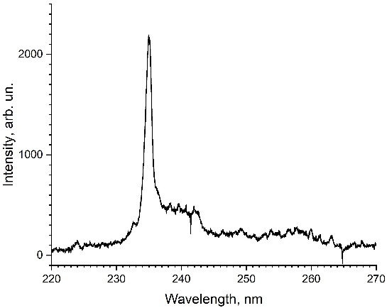

Fig.1. Figure Legends: 9 pt, roman, centered, first line indent 0 pt, spacing 6 pt before and after.

Figures: centered, first line indent 0 pt, spacing 6 pt before and 0 pt after.

Formulae: tab stops 8.5 cm, centered, numbers right aligned 17 cm, first line indent 0 pt, spacing 2 pt before and after:

, (1)

with no first line indent below.

References: 8 pt, roman, first line indent 0 pt, spacing 0 pt before. Heading: 10 pt, roman, centered, all capitalized. Follow the templates [1, 3, 5] and examples [2, 4] below.

References

1. Pezzagna S., Meijer J. Quantum computer based on color centers in diamond // Applied physics review, 8, 011308, 2021, doi: 10.1063/5.0007444
2. Maitrejean S., Perion D., Sundermann D. Nondestructive chemical identification using an x-ray transmission function obtained with the multi-energy method // Proceedings of SPIE «SPIE's International Symposium on Optical Science, Engineering, and Instrumentation, 1998, San Diego, CA, United States», 3446, p. 11011, 1998, https://doi.org/10.1117/12.312885
3. Bobrovnikov S. M., Matvienko G. G., Romanovsky O. A., Serikov I. B., Sukhanov A. Ya. Lidar spectroscopic gas analysis of the atmosphere. Tomsk: IOA SB RAS, 510 p., 2014 [in Russian]
4. Nakashima T., Satoh S., Tsuji K. Diamond laser crystal and method manufacturing the same // US Patent №4,950,625, 21.08.1990
5. [Electronic resource] // Official website CERN – URL: https://indico.cern.ch/event/212356/contributions/1507434/attachments/334362/466618/Detector_Based_Innovattions_Medical_Imaging_CT_n_PET_V2.pdf